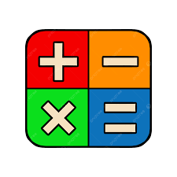Applications of Math
in our daily life

The components of this document:
1. Mathematics in Shopping and Money Management
2. Mathematics in Cooking and Baking
3. Mathematics in Time Management
4. Mathematics in Technology and Computers
5. Mathematics in Engineering and Construction
6. Mathematics in Medicine and Healthcare
7. Mathematics in Sports
8. Mathematics in Transportation and Travel
9. Mathematics in Weather Forecasting
10. Mathematics in Business and Economics
11. Mathematics in Science
12. Mathematics in Daily Household Activities
13. Importance of Mathematics in Daily Life
14. Conclusion
15.Sources

Why Mathematics is important in our lives?

Mathematics is one of the most important subjects in human life. It is not only studied in schools, but it is also used in almost every activity people do every day. Mathematics helps people think logically, solve problems, manage money, understand technology, and make better decisions. From simple tasks like telling time to advanced scientific discoveries, math plays a major role in modern life.
People often use mathematics without realizing it. Whether someone is shopping, cooking, traveling, using a smartphone, or playing sports, mathematics is always present. It is considered the universal language because it is used in science, engineering, business, medicine, and technology all around the world.
Let’s look at some examples:

1. Mathematics in Shopping and Money Management

One of the most common applications of mathematics is shopping and handling money. Every day, people use math to calculate prices, discounts, taxes, profits, and expenses.
How?
When people go shopping, they compare prices to choose the best product within their budget. Stores use percentages to offer discounts during sales. Customers also calculate the total cost of items before paying. In banks, mathematics is used to calculate interest rates, savings, loans, and investments.
Without mathematics, managing money correctly would be very difficult. Math helps people avoid overspending and allows businesses to make profits.
Example:
If a laptop costs $800 and there is a 15% discount:
- Discount amount = $120
- Final price = $680
People also use math to divide monthly salaries into categories such as food, transportation, education, and savings.

2. Mathematics in Cooking and baking

Cooking and baking require accurate measurements, which makes mathematics very important in the kitchen.

How?
People use fractions, multiplication, division, and measurement units while preparing food. Recipes often need adjustments depending on the number of people being served. Chefs and bakers must carefully calculate ingredients to maintain the quality and taste of food.
Mathematics also helps calculate cooking time and temperature. Professional bakers especially depend on precise measurements because small mistakes can ruin recipes.
Example:
If a cake recipe needs:
- 2 cups of flour for 4 people
To make the same cake for 8 people:
- 4 cups of flour are needed.
Cooking timers and oven temperatures also depend on mathematical calculations.

3. Mathematics in Time Management

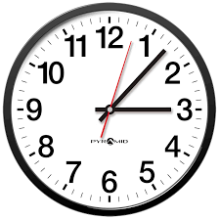
Time management is another important daily application of mathematics.

How?
People use math to read clocks, calculate durations, organize schedules, and plan daily activities. Students use math to divide study time between subjects. Workers calculate working hours and deadlines. Travelers calculate departure and arrival times.
Without mathematical understanding of time, organizing daily life would become confusing and inefficient.
Example:
If school starts at 7:30 a.m. and the trip takes 25 minutes, a student should leave home before 7:05 a.m.
Calendars, alarms, and digital clocks all depend on mathematical systems.

4. Mathematics in Technology and Computers



Modern technology would not exist without mathematics.

How?
Mathematics is the foundation of computers, smartphones, software, video games, artificial intelligence, and the internet. Programmers use mathematical algorithms to create applications and solve technical problems.
Computers perform millions of calculations every second. Internet security systems use mathematical encryption to protect users’ information. Social media applications also use mathematics to analyze data and recommend content.
Example:
Video games use math to:
- Calculate player movement
- Create graphics and animations
- Measure scores and speed
- Design virtual worlds
Artificial intelligence systems also depend heavily on statistics and mathematical models.

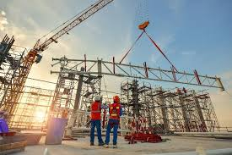
5. Mathematics in Engineering and Construction

Engineering is one of the fields most connected to mathematics.

How?
Engineers and architects use mathematics to design buildings, roads, bridges, and machines. They calculate distances, angles, areas, volumes, and material strength to ensure safety and stability.
Construction workers also use math to measure land, cut materials accurately, and estimate costs. Even small mathematical mistakes in construction can lead to dangerous problems.
Example:
Architects use geometry to design buildings with proper dimensions and balance. Engineers calculate the weight a bridge can safely support before construction begins.


6. Mathematics in Medicine and Healthcare

Mathematics plays a major role in hospitals, pharmacies, and medical research.
How?
Doctors use math to calculate medicine doses based on a patient’s age, weight, and condition. Nurses measure heart rates, blood pressure, and body temperature. Scientists use statistics to study diseases and test new medicines.
Medical equipment such as X-rays, MRI machines, and CT scans also depend on mathematical calculations and computer algorithms.
Example:
If a medicine requires 5 milligrams per kilogram of body weight, doctors must calculate the exact amount needed for each patient.
Statistics also help health organizations track disease spread and improve treatments.


7. Mathematics in Sports

Sports use mathematics in many ways.

How?
Players, coaches, and referees use math to calculate scores, distances, speed, averages, and game statistics. Teams analyze mathematical data to improve performance and create better strategies.
Mathematics is also used in designing sports equipment and stadiums.
Example:
In football, statistics measure:
- Goals scored
- Passing accuracy
- Ball possession
- Player speed
Athletes use mathematical analysis to improve training and performance.

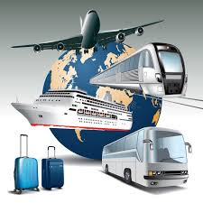
8. Mathematics in Transportation and Travel

Transportation systems rely heavily on mathematics.

How?
Drivers use math to calculate speed, fuel consumption, and travel time. Pilots and ship captains use mathematical navigation systems to travel safely. GPS applications calculate the shortest and fastest routes using algorithms.
Transportation companies use mathematics to organize schedules and reduce costs.
Example:
If a car travels at 80 kilometers per hour for 4 hours:
- Distance traveled = 320 kilometers
Airplanes also use mathematical calculations to determine fuel requirements and flight paths.

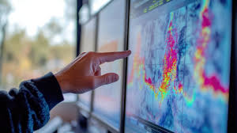
9. Mathematics in Weather
Forecasting

Weather prediction depends on mathematics and statistics.
How?
Meteorologists collect data about temperature, wind speed, humidity, and air pressure. Mathematical models analyze this information to predict weather conditions.
Without mathematics, weather forecasting would not be possible.
Example:
Weather apps use mathematical calculations to predict rain, storms, and temperature changes several days in advance.


10. Mathematics in Business and Economics

Businesses and economies depend greatly on mathematics.
How?
Companies use math to calculate profits, losses, salaries, production costs, taxes, and budgets. Economists analyze data and predict market changes using statistics and graphs.
Businesses also use mathematics to manage inventories and improve productivity.
Example:
A business compares monthly sales reports to determine whether profits increased or decreased.
Banks and stock markets also rely on mathematical analysis.

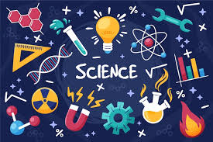
11. Mathematics in Science

Science and mathematics are closely connected.
How?
Scientists use mathematical formulas and measurements in physics, chemistry, biology, and astronomy. Experiments require accurate calculations and data analysis.
Many scientific discoveries would not exist without mathematics.
Example:
Physicists use equations to study motion, gravity, and energy. Astronomers calculate distances between planets and stars using mathematics.

12. Mathematics in Daily
Household Activities



People use mathematics at home every day.

How?
Families use math to:
- Pay bills
- Measure furniture
- Divide food
- Manage electricity and water usage
- Plan family budgets
Even simple activities like arranging objects or decorating rooms involve mathematical thinking.
Example:
A family may calculate monthly electricity costs to reduce spending and save energy.

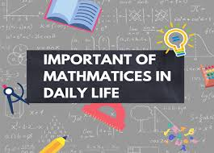
Importance of Mathematics in Daily Life:

Mathematics is important because it:
- Develops logical and critical thinking
- Improves problem-solving skills
- Helps people make accurate decisions
- Saves time and money
- Supports science and technology
- Builds analytical thinking skills
- Helps organize daily activities
Mathematics also prepares students for many careers such as engineering, medicine, business, computer science, architecture, and economics.

Conclusion:


Mathematics is an essential part of everyday life. It is used in shopping, cooking, technology, medicine, sports, transportation, business, and many other areas. People rely on mathematics to solve problems, make decisions, and improve their lives. Although many people think mathematics is only a school subject, it is actually a practical tool used everywhere in the modern world. Without mathematics, life would be less organized, less efficient, and much more difficult.

Sources:

1.Khan Academy:
https://www.khanacademy.org/?utm_source=chatgpt.com
2.Britannica-Mathematics:
https://www.britannica.com/science/mathematics?utm_source=chatgpt.com
3.Cuemath:
https://www.cuemath.com/?utm_source=chatgpt.com
4.BYJU’s Math Applications:
https://byjus.com/maths/uses-of-maths-in-daily-life/?utm_source=chatgpt.com
5.National Geographic Education:
https://education.nationalgeographic.org/?utm_source=chatgpt.com

